I233018
AbdulBasit
Lab7

Q1:
WRITE CODE:
#include <stdio.h>
#include <stdlib.h>
#include <fcntl.h>
#include <unistd.h>
#include <string.h>
#include <sys/stat.h>

//PIPE NAME
#define PIPE "/tmp/my_pipe"

int main()
{
// mkfifo(PIPE,0666); PIPE HAS BEEN MADE
char message[] = "Hello from producer !!";

int fd = open(PIPE,O_WRONLY);
if(fd == -1)
{
perror("Error opening FIFO for writing");
exit(EXIT_FAILURE);
}
write(fd,message,strlen(message)+1);

sleep(1);
close(fd);
printf("Message sent from producer and pipe closed");
return 0;
}
READ CODE:
#include <stdio.h>
#include <stdlib.h>
#include <fcntl.h>
#include <unistd.h>
#include <string.h>
#include <sys/stat.h>

//PIPE NAME
#define PIPE "/tmp/my_pipe"

int main()
{
char buffer [50];

int fd = open(PIPE,O_RDONLY);
if(fd == -1)
{
perror("Error opening FIFO for Reading");
exit(EXIT_FAILURE);
}
int bytes=read(fd,buffer,sizeof(buffer));

printf("\n%s",buffer);
sleep(1);
close(fd);

printf("\nMessage Received and Printed!");
unlink(PIPE);
return 0;
}
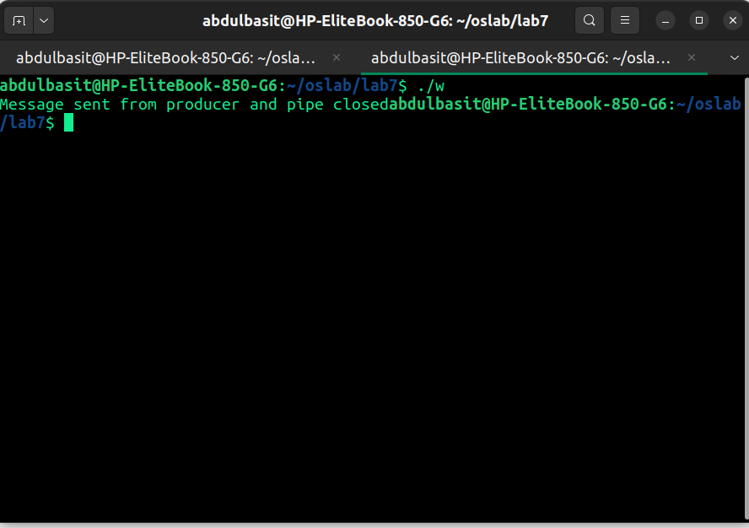
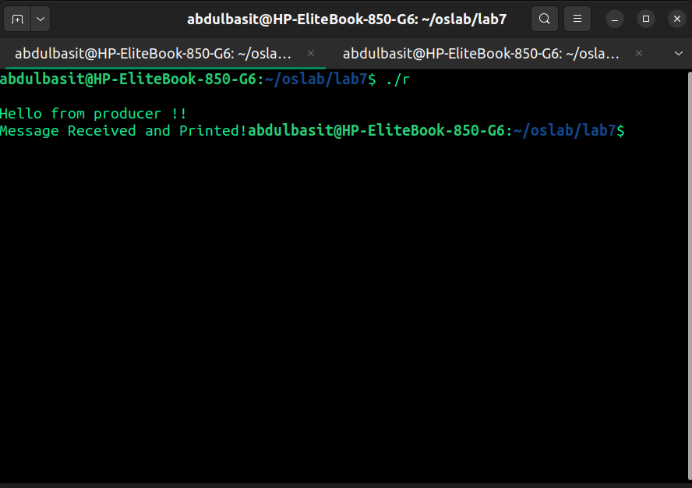
Q2:
READ CODE:
#include <stdio.h>
#include <stdlib.h>
#include <fcntl.h>
#include <unistd.h>
#include <string.h>

// PIPE NAME
#define PIPE "/tmp/my_pipe"

int main()
{
int fd;
char buffer[100];

// Open the FIFO for reading (Non-blocking)
fd = open(PIPE, O_RDONLY | O_NONBLOCK);
if (fd == -1)
{
perror("Error opening FIFO");
exit(EXIT_FAILURE);
}

// Read from FIFO
int x = read(fd, buffer, sizeof(buffer) - 1);
if (x == -1)
{
perror("Error reading from FIFO (No data or other issue)");
close(fd);
exit(EXIT_FAILURE);
}
else if (x == 0)
{
printf("No data available in FIFO. Exiting...\n");
close(fd);
exit(EXIT_FAILURE);
}
else
{
printf("Read successfully: %s\n", buffer);
}

close(fd);
return 0;
}
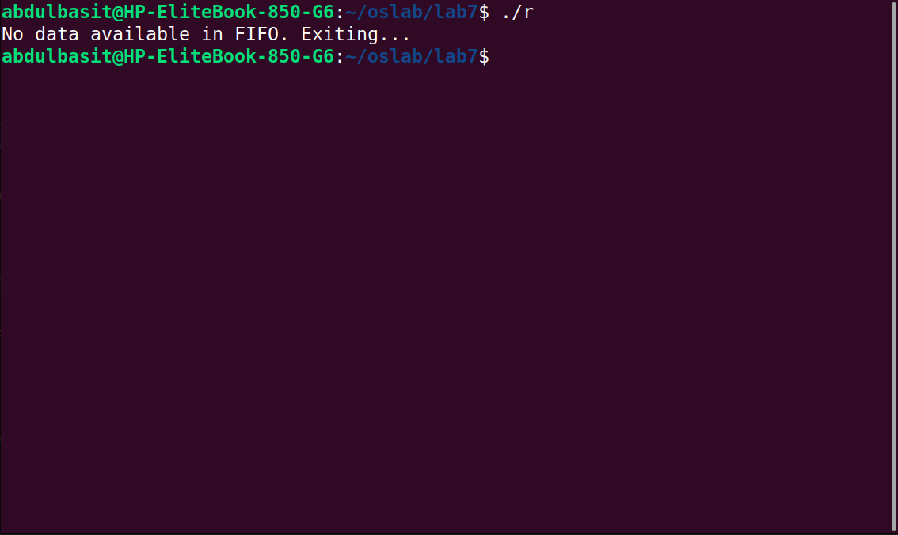

Q3:
#include <stdio.h>
#include <stdlib.h>
#include <fcntl.h>
#include <unistd.h>
#include <string.h>

//PIPE NAME
#define PIPE "/tmp/my_pipe"

int main()
{
int fd;
char message[] = "Hello from producer 1";

// Open the FIFO for writing
fd = open(PIPE, O_WRONLY);
if (fd == -1)
{
perror("Error opening FIFO for writing");
exit(EXIT_FAILURE);
}

// Try to write without blocking
if (write(fd, message, strlen(message) + 1) == -1)
{
perror("Error writing to FIFO (No reader present)");
}
else
{
printf("Message sent: %s\n", message);
}

close(fd);
return 0;
}
#include <stdio.h>
#include <stdlib.h>
#include <fcntl.h>
#include <unistd.h>
#include <string.h>

// PIPE NAME
#define PIPE "/tmp/my_pipe"

int main()
{
int fd;
char buffer[100];

// Open the FIFO for reading (Blocking mode so it waits for writers)
fd = open(PIPE, O_RDONLY);
if (fd == -1)
{
perror("Error opening FIFO");
exit(EXIT_FAILURE);
}

printf("Waiting for data...\n");

while (1)
{
int x = read(fd, buffer, sizeof(buffer) - 1);

if (x > 0)
{
buffer[x] = '\0';
printf(" %s\n", buffer);
}
else if (x == 0)
{
sleep(3);
else
{
perror("Error reading from FIFO");
break;
}
}

close(fd);
return 0;
}

